Fish Physiology Notes

Anatomy and Physiology
- Physiology:

Circulatory System

Respiration

Neutral Buoancy:

- How do sharks keep from sinking?

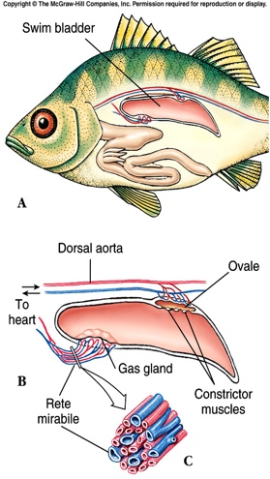
- What is a swim bladder?

Teleosts vs. Chondrichthians
- Teleosts:
- Chondrichthians:

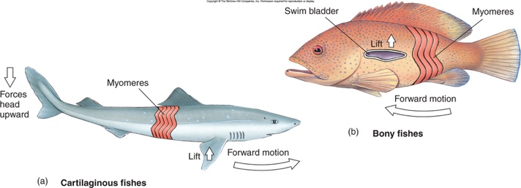

Osmotic Regulation
Freshwater fish are _______________________________

- kidney pumps_______________________________

Marine bony fishes are _______________________________

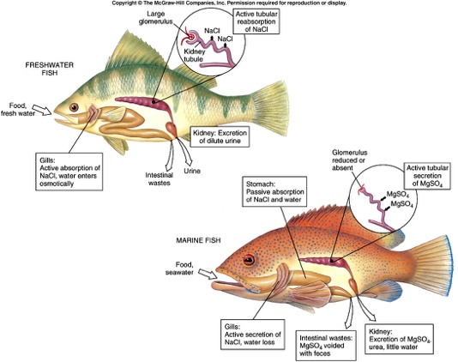
- unneeded salt is secreted _______________________ ____________________________________

Reproduction
- Most sexually reproduce and have separate sexes
- __________________________-eggs develop outside the female.
- __________________________- eggs are fertilized internally and hatch and develop inside the mother. Don’t receive nutrients from her body.
- __________________________-Most fish externally fertilize eggs in a large group. No parental care.
- __________________________- a few species care for eggs and/or larvae by protecting them in their mouths.

Life Cycle of Fishes

Movement
- Locomotion
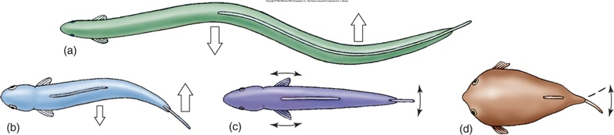
  - myomeres:

