Cnidarians (Phylum Cnidaria) Day 1
- Basic characteristics:
  - _______________________________- symmetry
  - ______________________________________________________________
    - ____________________ covers body surface
    - ____________________ lines internal body cavity; specialized for digestion
  - ___________________________ (stinging cells) within specialized cells (cnidocytes) on tentacles. Used for protection and feeding
  - _________________________________________________ (sac-like with mouth only)
  - ________________________________ throughout body coordinates movements
  - Have _______________________________ but no eyes
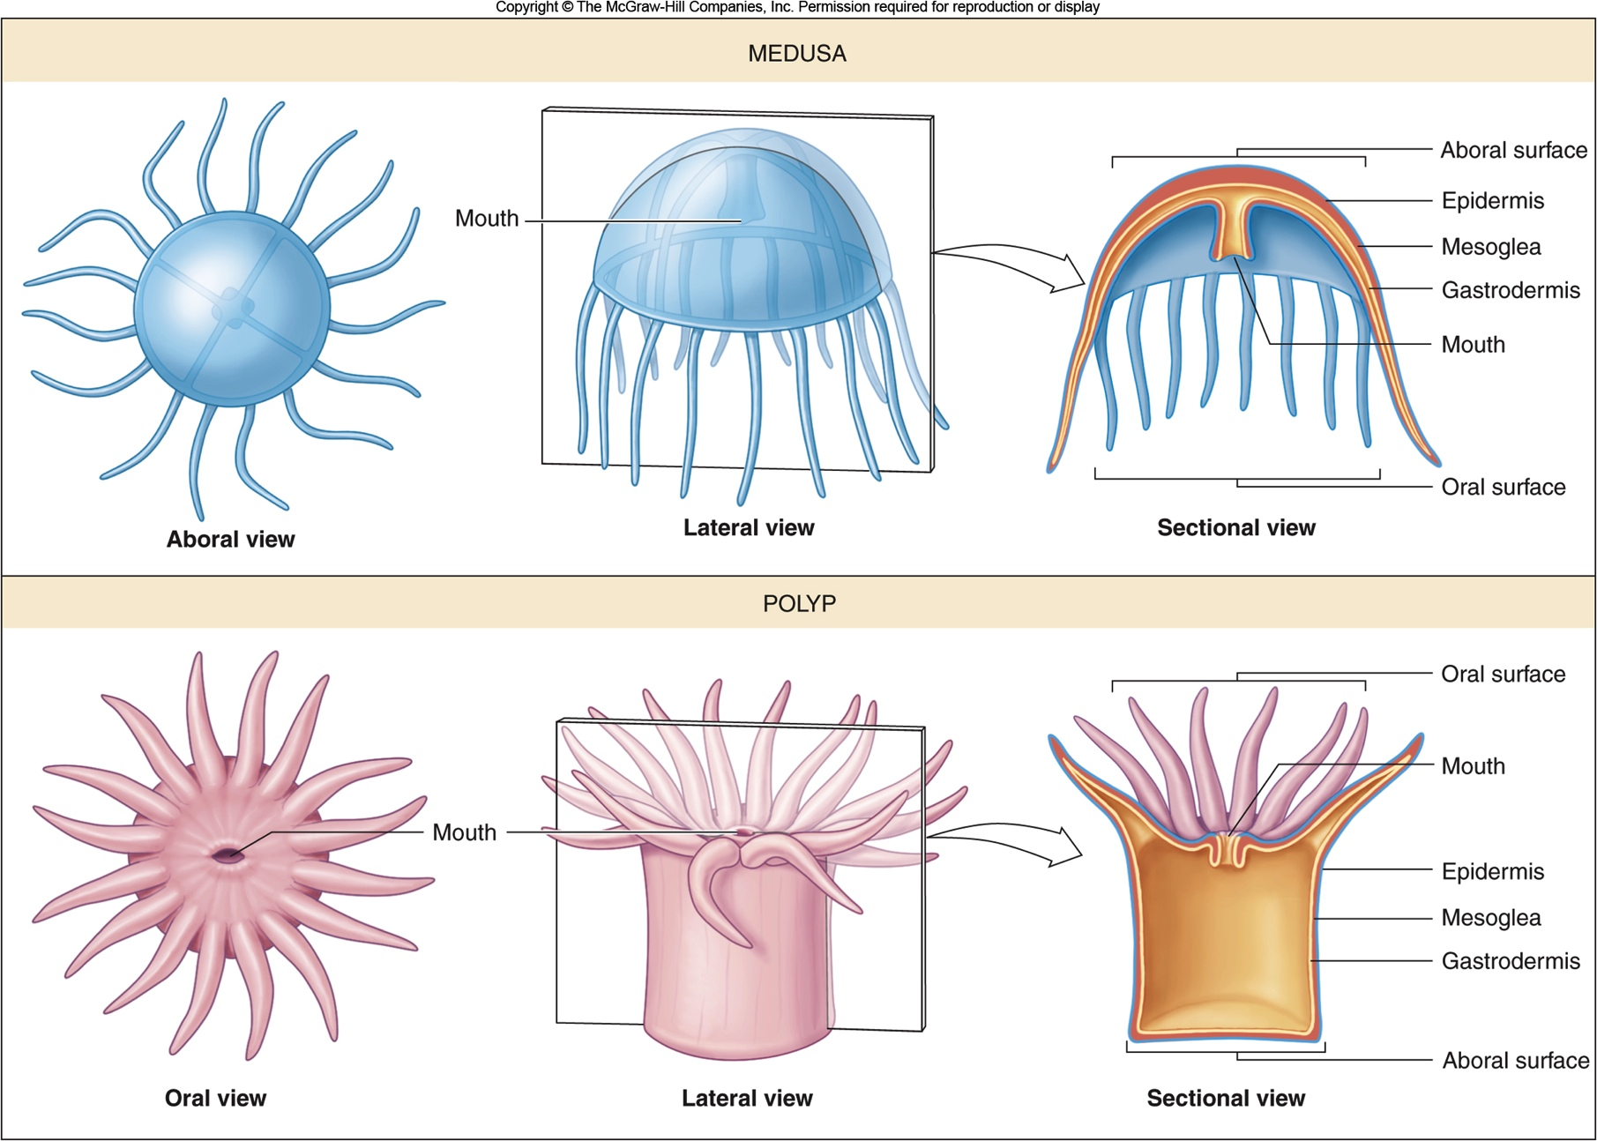
Two Body Forms:
____________________________ – free-swimming form that is transported by water currents, mouth with surrounding tentacles positioned downwards
_____________________________ – attached form with mouth and tentacles positioned upwards
- All cnidarians go through both phases in their life cycle.

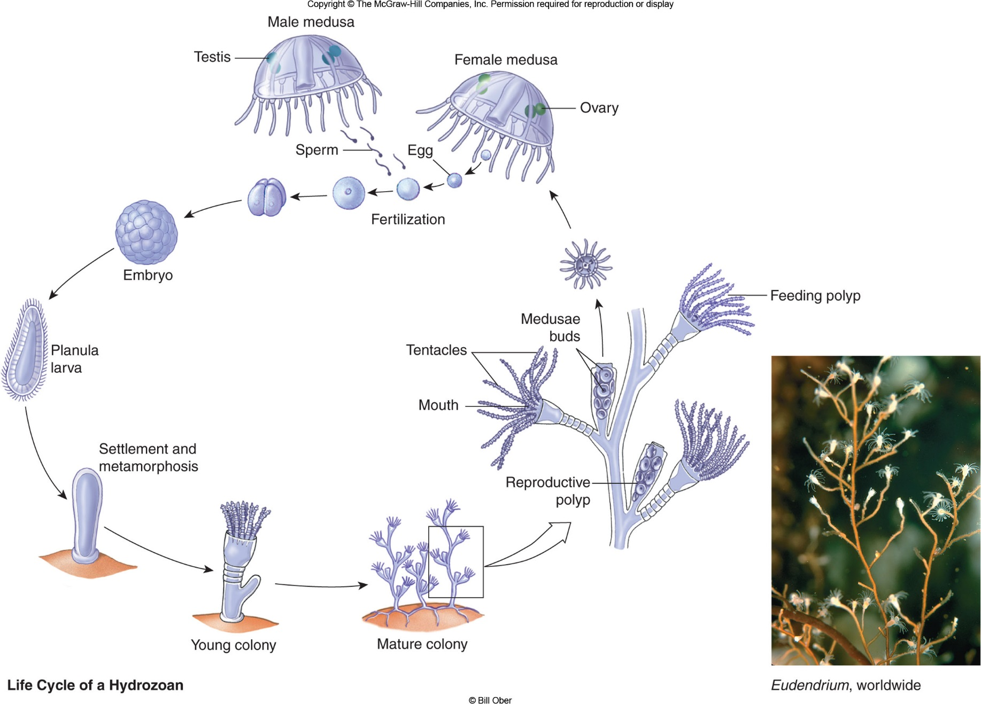
Nematocysts and Cnidocytes
- Weapons that are used for protection, stunning prey, defense.
- ______________________- organelle constructed as an explosive harpoon tipped with neurotoxin.
- _______________________- Cells containing nematocyst. Located on the tentacles.
Classes of Cnidarians
Hydrozoans

- Portuguese man-of-war (Physalia) – siphonophore carried by a gas-filled float; some of the polyps with long tentacles armed with stinging nematocysts
Scyphozoans

- Move by rhythmic muscular contractions of the bell, but carried by water currents
Cubozoans
- _____________________________________-Small medusae with tentacles armed with very powerful nematocysts that may cause death in humans
- Called the Box jellyfish or sea wasp
Anthozoans

- Most reef-building corals are colonial: interconnected polyps that develop asexually from a single polyp

Assignment: Cnidarian Stings Webquest

