Fish Physiology Notes

Anatomy and Physiology
- Physiology:

Circulatory System

- Deoxygenated blood enters 1st chamber of heart from body (atrium)
- 2nd chamber pumps this blood into gills (ventricle)
- Gas exchange takes place in gills
- Oxygenated blood carried to rest of body

Respiration
- How do fish keep their gills irrigated?

- What is counter-current diffusion?

Neutral Buoyancy:

- How do sharks keep from sinking?

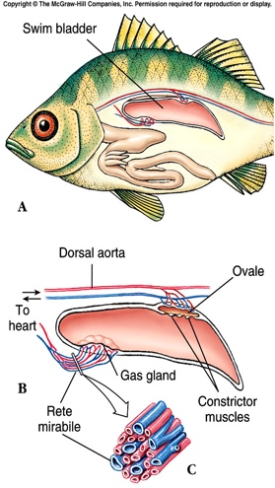
- What is a swim bladder, and which class of fish is it found in?

Teleosts vs. Chondrichthians
- Teleosts:
- Chondrichthians:

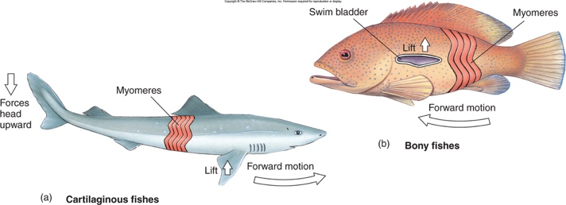

Osmotic Regulation
Marine bony fishes are _______________________________

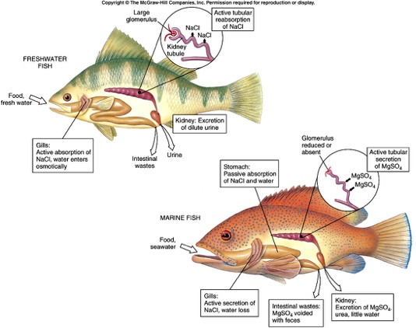

- unneeded salt is secreted _______________________ ____________________________________

Reproduction
- Most sexually reproduce and have separate sexes
- __________________________-eggs develop outside the female.
- __________________________- eggs are fertilized internally and hatch and develop inside the mother. Don’t receive nutrients from her body.
- __________________________-Most fish externally fertilize eggs in a large group. No parental care.
- __________________________- a few species care for eggs and/or larvae by protecting them in their mouths.

Life Cycle of Fishes

Movement
- Locomotion
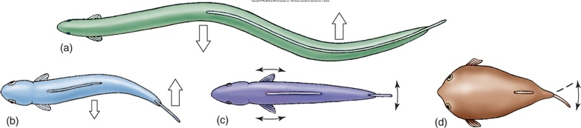
  - myomeres:

Schooling and Shoaling
- Shoal:

- School:
  - How is a school’s behavior controlled?

