Fishes Note Guide

Marine Fishes:

Basic Characteristics of all fishes:

Types of Marine Fishes:
1. __________________ (_________________________)

2. __________________ (_______________________________)

3. __________________ (_________________________)

Cartilaginous Fishes (Class ________________________________________)
  - Sharks, rays, skates, and ratfishes
- Basic Characteristics:
  - Skeleton of ___________________
  - Heterocercal tail: _________________________________
  - Mouth is always _________________
  - _________________ scales
  - ___________________
  - 5-7 _____________________ open directly into the water in most species
  - ________________in many species (openings on head used to bring water for respiration without having to open the mouth)
  - Males in most species have _____________; projections of the anal fin used in copulation
  - Buoyancy aided by ______________________________________

Bony Fishes (Class ________________________________)
- Basic Characteristics:
  - Skeleton composed of _____________
  - __________________tail (two lobes of equal size) that provides forward thrust
  - Flat bony scales (_________________________)
  - Bony ______________________covers the gills
  - _______________________ used for buoyancy control (absent in some demersal species)
  - _____________________ for sensory information
  - Over 31,000 species known (marine and freshwater), about half of all known vertebrates species
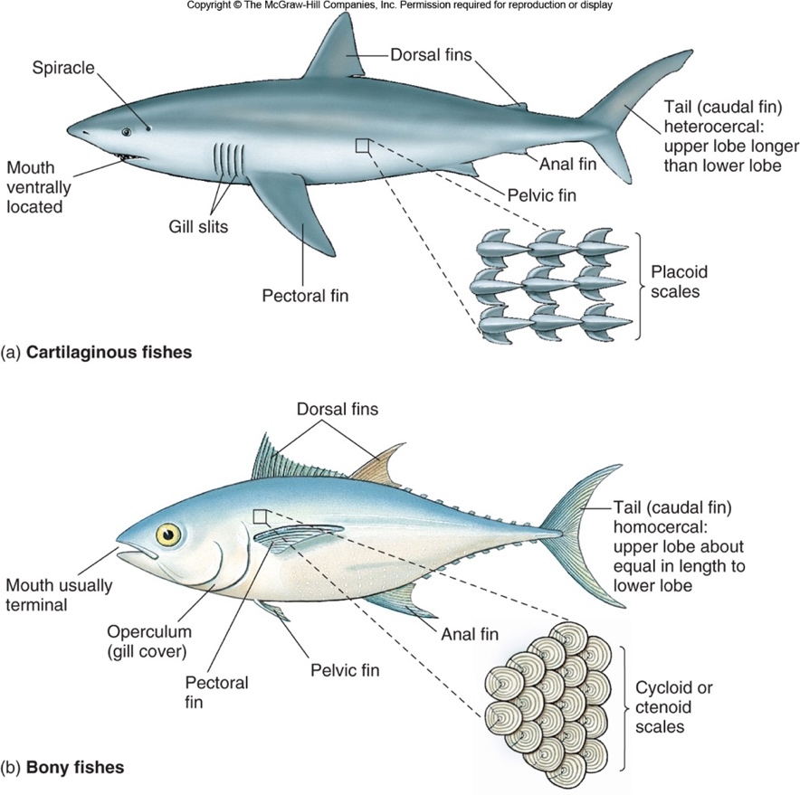
Bony Fishes: 2 Types

Assignment:
- Make a poster comparing and contrasting Chondrichthyes and Osteichthyes.
- List all the characteristics of all fish
- For each class of fish, describe their gills, tail, buoyancy, scales, mouth position
- Also list at least 2 specific species for each class including: scientific name, common name, habitat, conservation status. Include a picture (drawn or printed out with photo credits)
Total points possible = 35 DUE ________________________

