Water and Seawater Properties Notes Date_____________________

Overview

Freezing and Boiling Points
- Freezing point =
- Boiling point =

Global Thermostatic Effects
- ___________________________________________________________________
  - Equatorial oceans do not boil
  - Polar oceans do not freeze solid
- ____________________________________________________________________
  - ______________________________________________________________ ______________________________________________________________
- ______________________________________________
  - Land areas have greater range of temperatures from day to night and during different seasons
  - _______________________________________________________________ _______________________________________________________________.

Water Density and Temperature
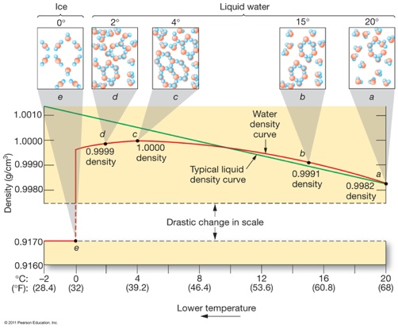

Water Density
- ______________________________________________________________________ ______________________________________________________________________.
- Dissolved solids also reduce the freezing point of water.
  - Most seawater never freezes.

Salinity

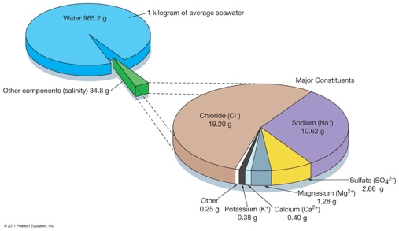

Salinity Variations
- Open-ocean salinity is ____________________________
- _____________________________________________________________.
  - An influx of freshwater lowers salinity or creates brackish conditions.
  - A greater rate of evaporation raises salinity or creates hypersaline conditions.
  - Salinity may vary with seasons (dry/rain).

Processes Affecting Salinity
- __________________________________________________________________
  - Runoff, melting icebergs, melting sea ice
  - Precipitation
- __________________________________________________________________
  - Sea ice formation
  - Evaporation

Earth’s Water
- ______________ in the world ocean
- 2.15% frozen in glaciers and ice caps
- 0.62% in groundwater and soil moisture
- 0.02% in streams and lakes
- 0.001% as water vapor in the atmosphere

Surface Salinity Variation

- ____________________________________
  - __________________________________
  - Abundant sea ice melting, precipitation, and runoff
- __________________________________ near equator
  - ______________________________
  - High precipitation and runoff
- __________________________________
  - ________________________________
  - Warm, dry, descending air increases evaporation

Global Salinity

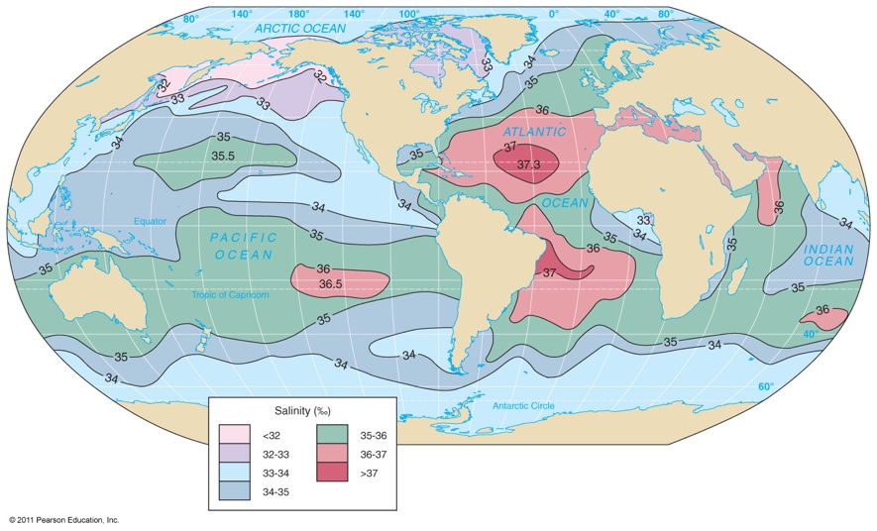

Salinity Variation with Depth
- Low latitudes – salinity decreases with depth
- High latitudes – salinity increases with depth
- Deep ocean salinity fairly consistent globally
- ______________________________________________________________________

Seawater Density
- ______________________________________________________________________
  - Greatest influence on density
- ______________________________________________________________________
- ______________________________________________________________________
  - Does not affect surface waters

Osmoregulation
Living_________________________________________________________________________
  - Water travels down the concentration gradient, so _______________________ ________________________________________________________________
Must ________________________________________________________________________
  - ____________________________________ have special glands that remove salt and other electrolytes
  - ____________________________________ have specialized kidneys to remove salts and flush them out with their urine
  - ____________________________________ can generally match their internal salinity to their surrounding environment, but cannot adapt quickly to changing salinity.
  - ____________________________________ can either live in salt water or freshwater, but not both.

