District Day Recap:

- “Here’s to all the teachers who are flying under the radar….not getting much attention. Their engaging lessons aren’t on Twitter. Their cool interactions with kids aren’t captured on YouTube. But they’re still crushing it. And they’re making a difference for a lot of students” I see you ALL. I see the amazing things you are doing. Keep it up. You ARE making a difference.
- 3 Quick, engaging activities

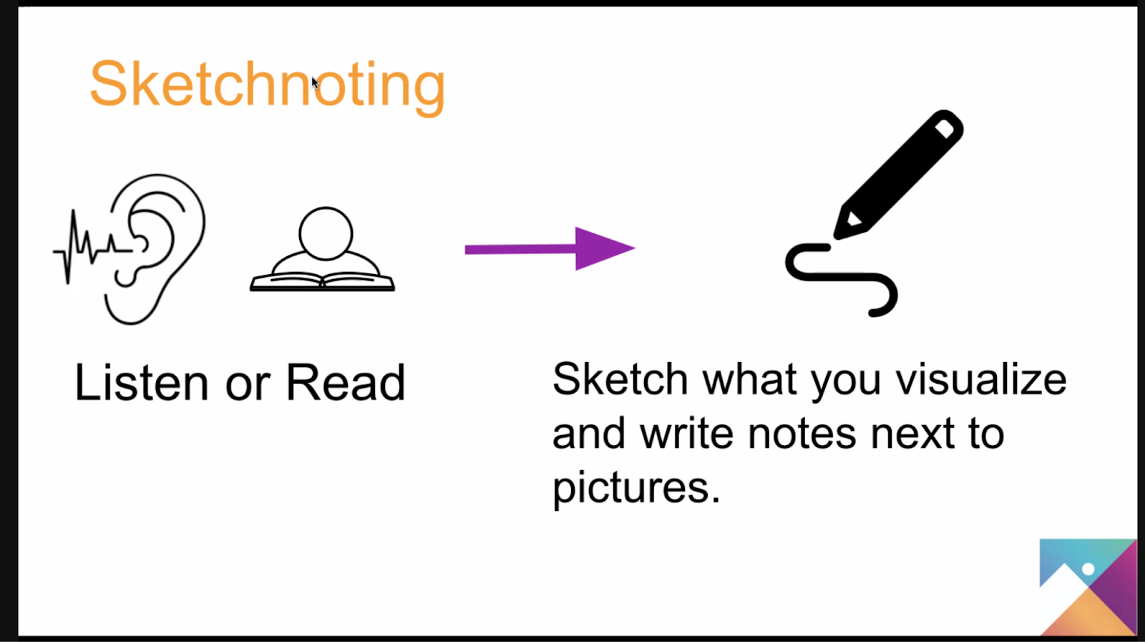
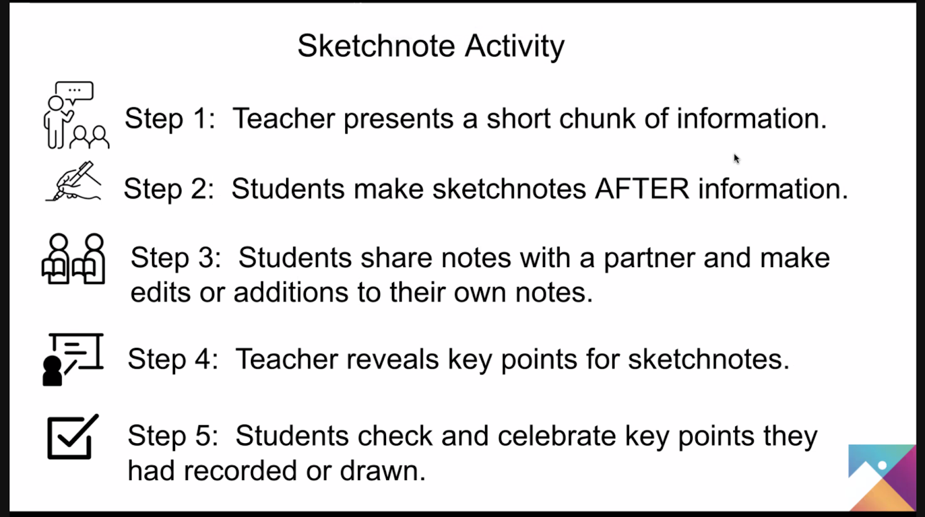
  - Sketch Notes
  - Listen Right https://www.tes.com/en-us/teaching-resource/kagan-structures-14-listen-right-note-taking-page-key-ideas-and-key-points-12264698
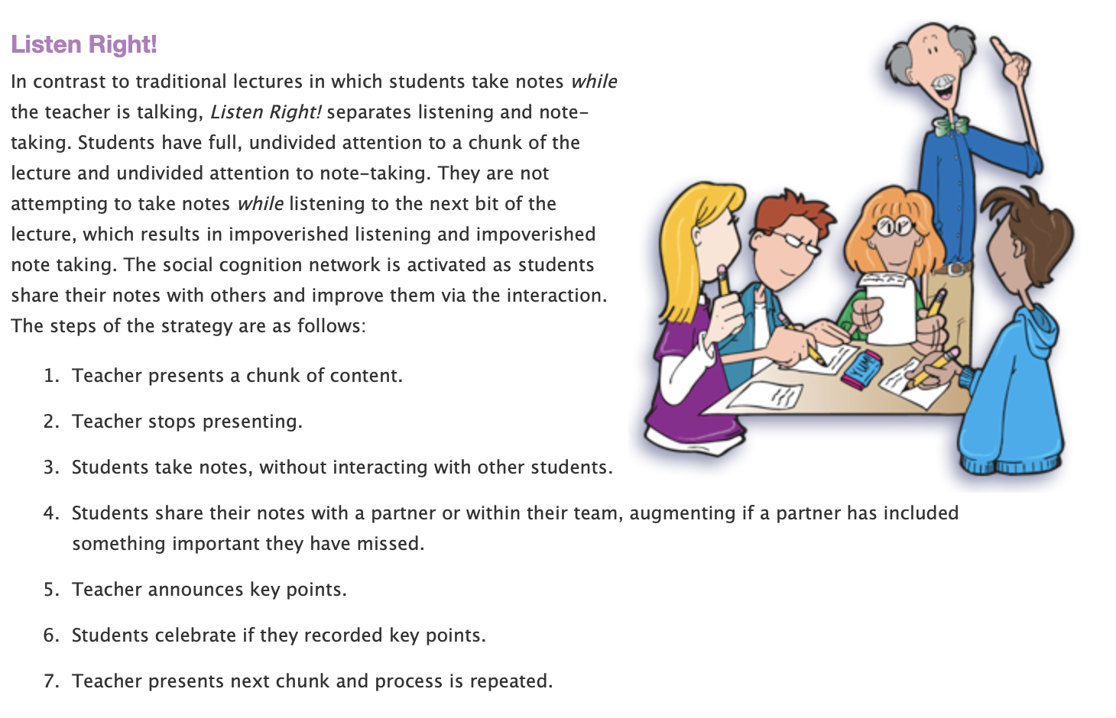

  - Word, Phrase Sentence
OnceOOnce the passage has been read once (either by you or by students), ask students to:

- Find a mathematical word that captures your attention (unusual, repeated, unknown, powerful, important)
- Share out words and why, teacher write down
- Find a phrase that is meaningful to the passage
- Share out and why, teacher writes down
- Find a sentence that is meaningful to the passage
- Share out and why, teacher writes it down
- Use the words, phrases, and sentences to write a summary
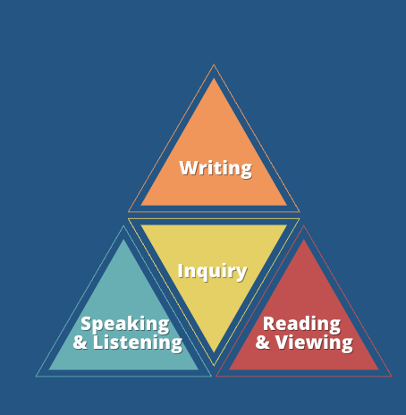
WISR – Teaching WISR, Not Harder
- New Teacher Project Findings:
- Students need consistent opportunities to work on GRADE-APPROPRIATE ASSIGNMENTS
- Students need STRONG INSTRUCTION where students do most of the thinking in a lesson
- Students need DEEP ENGAGEMENT in what they’re learning
Teachers need to include ALL STUDENTS IN THEIR HIGH EXPECTATIONS and believe every student can meet grade-level standards https://tntp.org/assets/documents/TNTP_The-Opportunity-Myth_Web.pdf

- We should be incorporating at LEAST ONE element of WISR in every lesson, with a priority on Speaking and Listening
- Business Items
  - Math Inventory
    - Fall window: Aug 16th – Sept 13th, if you need to give the assessment outside of the window, your principal must contact Hal Sanderson
  - Instructional Guides/Curriculum Maps Updates
    - Priority standards highlighted in the year at a glance
    - New unit guides for every unit with the following information:
      - Suggested pacing
      - Links to the unpacked standards
      - End of unit competencies – what students should know by the end of the unit
      - Scaffolding in action – suggestions for ways to scaffold each lesson and each part of the lesson
      - Priority lessons are highlighted
      - Links to resources
      - Learning Intentions and Success criteria for each lesson
  - Tentative new math pathways for high school: https://docs.google.com/document/d/1HKNVuMB7MHyG64Z_kvGdLSudfCPj0u5QbFn4tKf75C4/edit
  - Math revisions timeline:
    - 2023 – 2024 – review and revise
    - 2024 – 2025 – adopt and introduce
    - 2025 – 2026 - implement
    - 2026 – 2027 – assess – Word on the street is that the math assessment will be shifting to a task-based assessment

