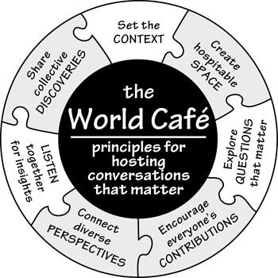

What is a World Café?

An “open space” protocol for talking and thinking more deeply about a particular issue, World Café is designed primarily to generate collective knowledge sharing, webs of personal relationships, and new possibilities for action.

World Café Protocol

- Provide a challenging, open-ended question to the whole group, or provide a different question at each table
  - Example: How can we prepare our students to compete in a global economy?
- At your table share and discuss your responses to this question. Use the chart paper to organize and represent your ideas – use symbols, organizers, pictures, words.
- Choose a “host”, someone who will stay at the table and articulate what was discussed with the next group.
- When time is signaled, everyone moves to new tables, mixing with whoever shows up.
- The host of each table shares what was discussed and new participants add their thoughts and ideas to what was previously discussed; add the ideas to the chart paper.
- Continue until the time is up.

Café Etiquette & Tips

- CONTRIBUTE your thinking and experience
- LISTEN to understand
- CONNECT ideas
- LISTEN TOGETHER for patterns, insights, and deeper questions—notice that individual conversations are part of and contribute to a larger field of collective knowledge and wisdom.
- Have materials available for visually representing key ideas – markers and paper.
- Honor the social nature of learning and community building

