Don't Tap on The Glass: Making Fishbowl Discussions Work for You
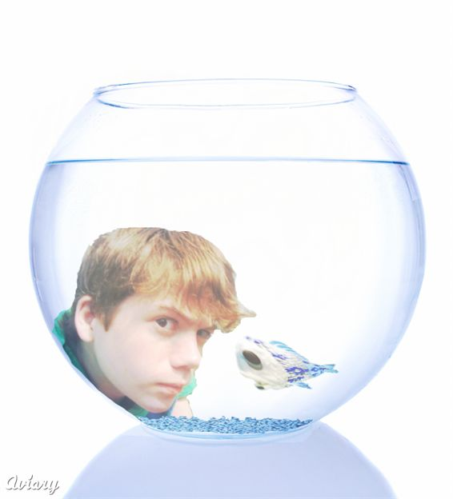
This activity requires 30-45 minutes.

Purpose:
Fishbowl activities force participants to listen actively to the experiences and perspectives of a specific group of people. A student fishbowl gives teachers an opportunity to hear the experiences, ideas, and feedback of students while giving the students an opportunity to be active in the dialogue.
Preparation:
The most important step to a successful fishbowl discussion is modeling and establishing expectations. The more time you spend on this, the happier you will be with your discussions. Modeling and showing students what to do is not a 5-minute process. Plan an entire day to prepare your students; it does take that long. You will not be doing the actual fishbowl discussion on the same day you prepare for it. Additionally, on the day of the discussion, you may want to review the expectations and procedures before they begin the conversation. So how do you prepare?
- Begin by introducing the concept of fishbowl discussions.
- Show them the video of an 8th grade class doing a fishbowl discussion. The link below is a discussion on assisted suicide and comes from the “Word Generation” website (http://wg.serpmedia.org/video_debate.html). Before showing the clip, ask students to pay attention to what students both inside and outside the circle are doing. Show clip #2.
- At the end of the clip, ask students to point out what they saw.
- What did students inside the circle do?
- What were the students outside the circle doing?
- Did the students outside the circle speak?
- When did they speak and what did they speak about?
- What did students inside the circle speak about?
- What phrases did they hear inside the circle that indicated whether a student agreed or disagreed with another one?
- What was the teacher expecting them to do?
- What two questions did she ask them?
- You may want to make a list of their responses on the board. Show clip #3 to illustrate how the next group makes improvements on what their peers have previously done. Notice the sign that the teacher has hanging in her room: “We strive for authentic conversations that are academically rich.” Discuss what that phrase means.
- Hand out the paper where students will take notes the next day. Explain each section of the paper and what you expect from them. Have them practice the academic sentence starters with their partner so they get a feel for them. I usually collect this paper at the end of the day and pass it out the next day when we do the discussion.

Instructions for the Fishbowl Discussion Day:
The following steps will set the ground rules and review the expectations from the previous day’s preparation.
- One important ground rule must guide the participation of the observers: During the course of the fishbowl, observers are not allowed to speak. Their job is to listen and learn from the fishbowl students. Mention that the observers will have an opportunity to discuss any issues that emerge later when they are asked to assess the discussion.
- If possible, assign one of the fishbowl students the role of facilitator. It will be her or his responsibility to ask questions, facilitate the fishbowl discussion, and make sure everyone has an opportunity to talk. If necessary, you can play the role of facilitator, but the discussion will be more authentic if you expect the students to conduct it themselves.
- Time the rounds for the discussion – about 5 minutes each. Once the round of discussion is stopped, ask the fishbowl observers to explain what they saw as far as academic and authentic conversation is concerned.
- Switch roles. Have those inside the fishbowl sit out, and those outside the fishbowl come to the inside circle. This is easily facilitated if you divide your number of students by 8 and then put them in that many groups (for example, if you have 32 students, you will have 8 groups of 4). Prior to the fishbowl discussion, have smaller groups meet to discuss the issue you would like them to discuss, then when they get their turn in the larger fishbowl discussion, they will have something to say.
- Repeat this process until everyone has had a chance to participate inside the circle. If you have an odd number of students, you can always leave a few chairs open for roving fish to swoop in and out of as they have a relevant point to share.

Assessing and Using Fishbowls in Your Classroom
Attached you will find a Common Core aligned rubric for assessing discussion within the fishbowl. This could be used by the teacher, peers, or the students themselves.

There are so many ways to use this technique! Here are some ways we have used it:
- To discuss a topic for argumentative writing as a prewriting activity.
- To discuss a novel when we’re half way through and predict what will happen next.
- To discuss a novel at the end. The teacher and students submit questions into a pile. Students inside the fishbowl draw a question, discuss it, then draw another one until their allotted discussion time is up.
- With literature circles, one literature circle is inside a fishbowl, another is observing, and then they switch. This allows students to give feedback on how their peers’ literature circle discussions are going. This also allows multiple fishbowl discussions to happen at the same time and gives more students an opportunity to respond.
- As a way to explore multiple sides of an abstract idea with informational text. Divide the class into 8 different groups. Have each group read a different piece of informational text on the same idea. (For example, the concept of courage.) Have students read and annotate the text within their groups, answer the same general question. (“What are the characteristics of courage? How does this article demonstrate that?”) Then have the students choose one person from each group to be inside the fishbowl to discuss. This discussion lasts longer – about 25 minutes. In that time, students from the group must tap their group member on the shoulder to tag them out, and join the discussion. Everyone in the group is required to tag in at least once when they have something to add.
- We are sure there are many more ways you can find to use this! And students BEG us to do it again!

