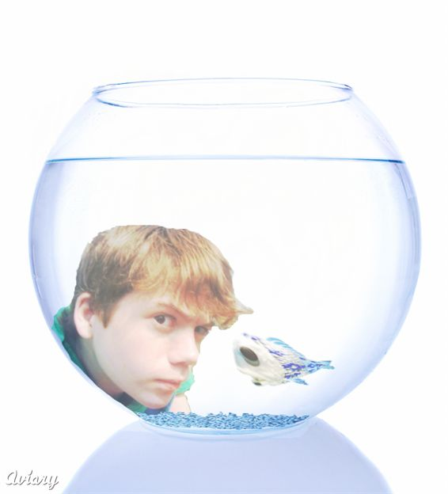
Name: ____________________________
Teacher Name: _____________________
Class and Period: _____________________
Date: ______________________________

FISHBOWL DISCUSSION - OUTSIDE

Let the debate begin! In order to facilitate discussion, we are going to have a ‘fishbowl’. Eight students chosen at random will sit in the center of the ‘fishbowl’ and discuss the assigned topic. They will discuss and debate the chosen question thoroughly until their time is up. The teacher will monitor the discussion. If you are in the circle, your job is to participate in the discussion. If you are outside of the circle, you may not talk and must take notes. In each of the columns below, write 10 things that were said in the inner circle (for a total of 30 things). You must write your classmate’s name as well as what they said.

AHA! | HMMM… | HUH?

FISHBOWL DISCUSSION – INSIDE

As you discuss in the circle, we need to hear you using academic language. This is not just a discussion with friends. Though you do not need to raise your hands to participate, we are expecting this to be an academic discussion. Remember to use the academic vocabulary you have learned. Also, use these starter phrases to begin your responses:

STARTING A DISCUSSION
I think __________________________ because __________________________.
My theory is __________________________ because __________________________.
I question __________________________ because __________________________.
The text says __________________________ so __________________________.
I predict __________________________ because __________________________.
My claim is __________________________ because __________________________.
In infer __________________________ because __________________________.

DISAGREEING
I disagree with ______ because . . .
As a rebuttal to ______’s point, ______

AGREEING
I agree with ______ because ______
I agree with ______ and would like to add ______
There is ample support for ______’s point for example ______

Expressing an Opinion
I think/believe that . . .
It seems to me that . . .
In my opinion . . .

Predicting
I guess/predict/imagine that . . .
Based on . . ., I infer that . . .
I hypothesize that . . .

Asking for Clarification
What do you mean?
Will you explain that again?
I have a question about that.

Paraphrasing
So you are saying that . . .
In other words, you think . . .
What I hear you saying is . . .

Soliciting a Response
What do you think?
We haven’t heard from you yet.
Do you agree?
What answer did you get?

Acknowledging Ideas
My idea is similar to/related to ______’s idea.
I agree with ________ that ___________.
My idea builds on _________’s idea

Reporting a partner’s idea Partner
______ indicated that . . .
______ clarified that. . .
____ pointed out to me that . . .
____ emphasized that . . .

Group Reporting
We decided/agreed that . . .
We concluded that . . .
Our group sees it differently.
We had a different approach . . .

